**Data 1202-Data Analysis Tools Analytics**

Project-3

2025-03-13

Prepared By: Group 8

|  |  |
| --- | --- |
| **Name** | **Student ID** |
| Akshara Chunduri | 100992816 |
| Hrithik | 101002114 |
| Ram Charan Vallabhaneni | 101003650 |
| Sai Prakash | 101001356 |

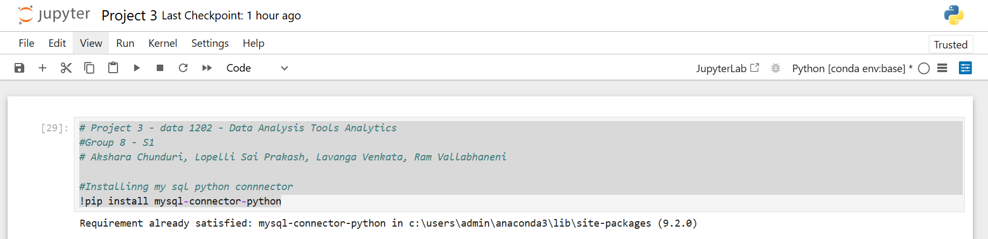

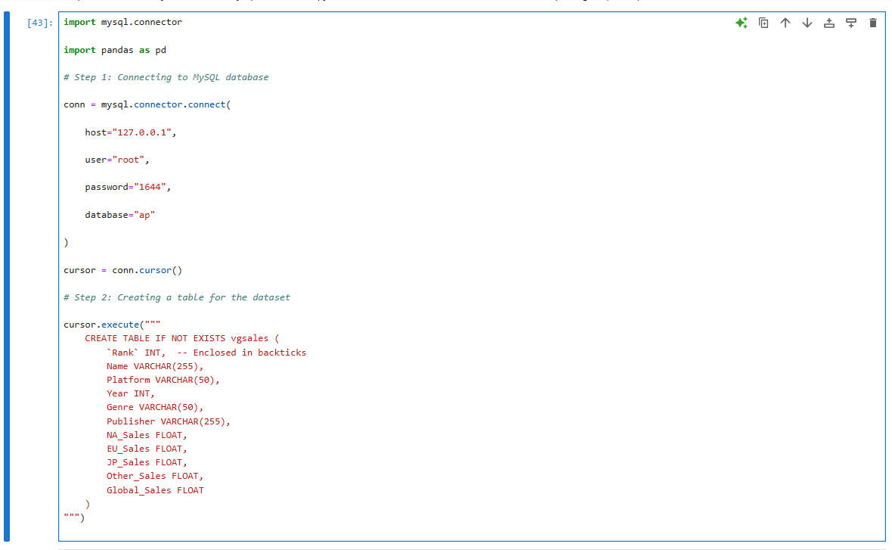

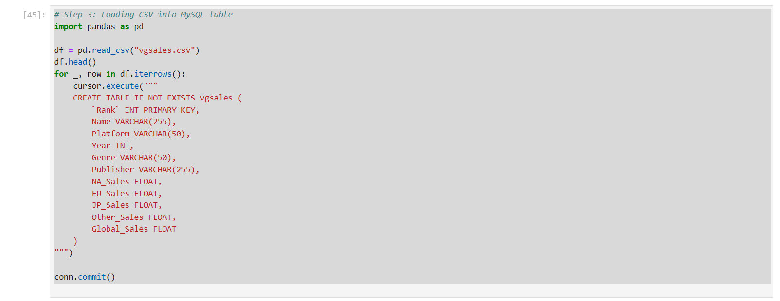

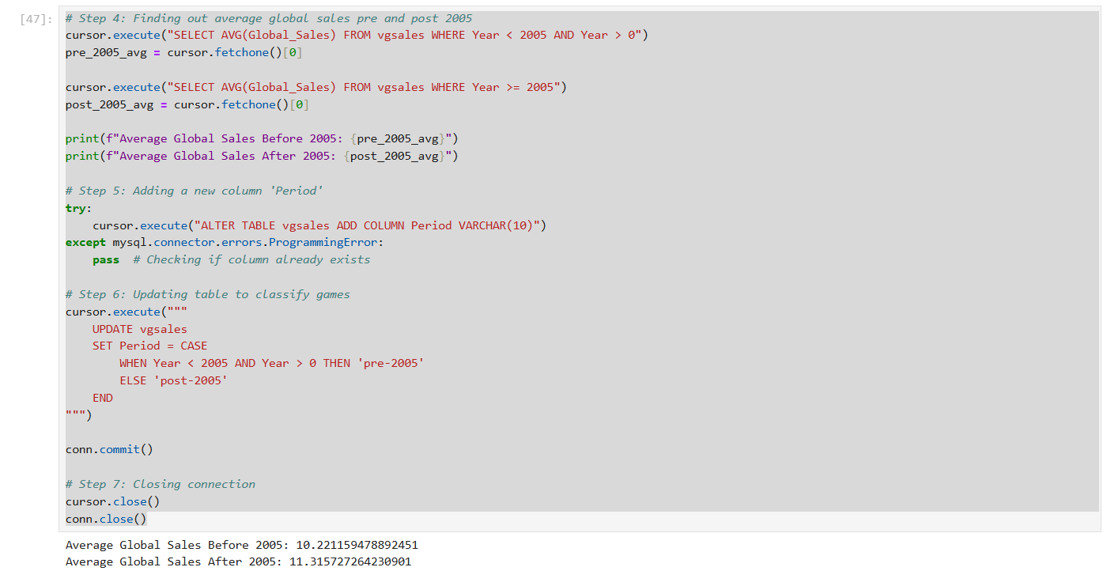

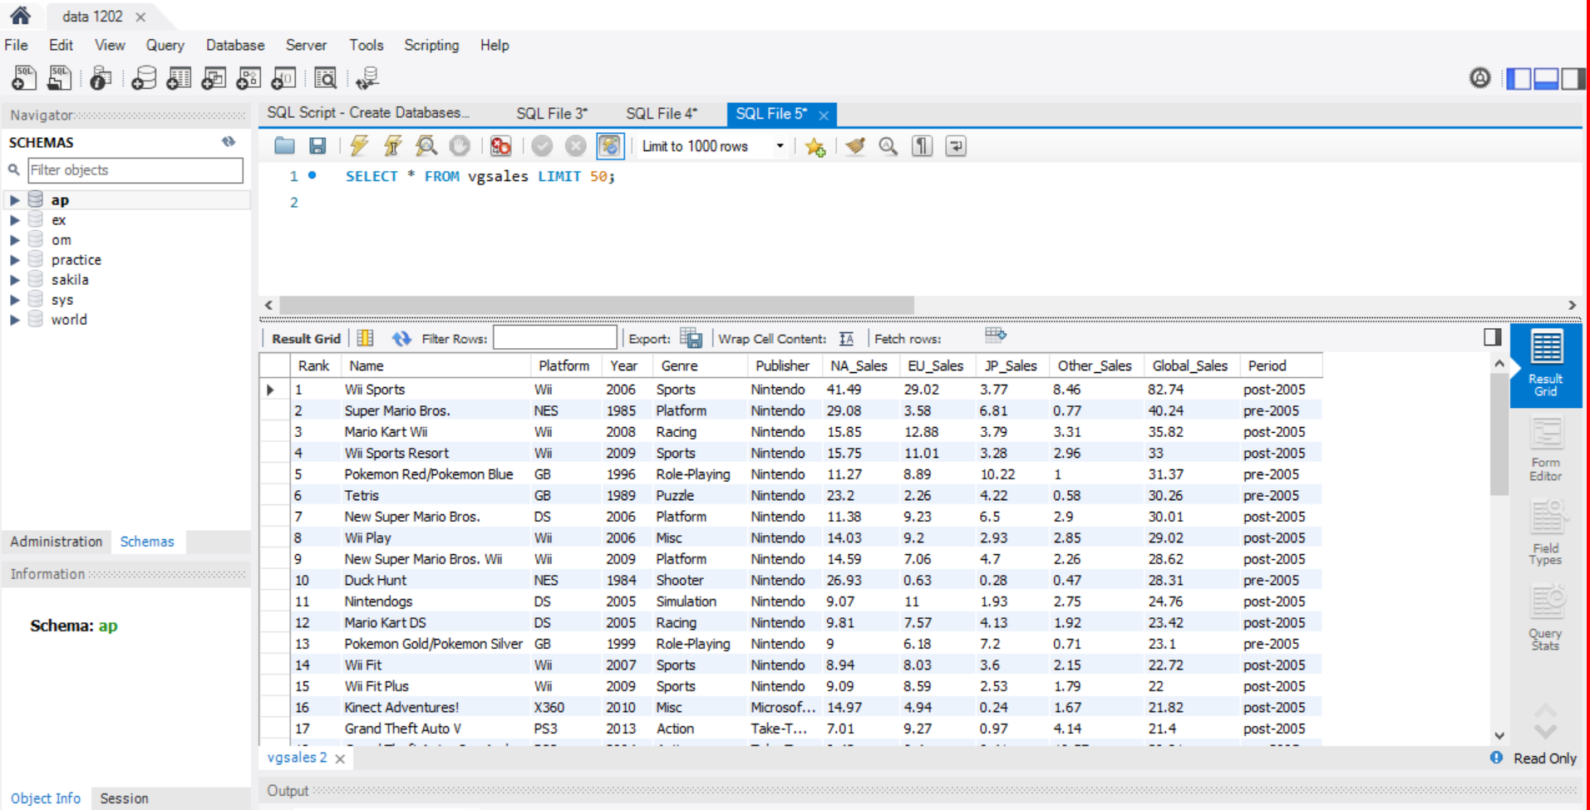

**Report:**

For this project, we worked with the same video game sales database from Project 1, but instead of using Pandas in Python, we used Python as an interface to a MySQL server to answer the given questions.

Understanding the Questions

We needed to:

1. Determine whether the average global sales were higher before or after 2005.
2. Create a new column that categorizes records as "pre-2005" or "post-2005."

Although we had to write SQL queries and run them in Python rather than utilizing Pandas to handle the data, these tasks were comparable to those we completed in Project 1.

**Comparison to Project 1:**

In Project 1, working with Pandas was pretty straightforward—we just loaded the CSV file, cleaned the data, and used built-in functions to calculate averages. It was quick and easy to write the code and see the results. However, in Project 3, things were a bit more complicated because we had to connect Python to MySQL, write SQL queries, and then fetch the results back into Python. While this made the process feel more structured, it also required extra steps and more careful query writing. In terms of performance, MySQL is better for handling large datasets, whereas Pandas might slow down when dealing with a lot of data. But in the end, both approaches gave us the same results. Project 1 felt simpler and more intuitive, while Project 3 helped us understand how databases work and how to use SQL efficiently within Python.

**Challenges:**

* Setting Up and Connecting to MySQL:  
  In contrast to Pandas, which allowed us to begin data analysis right away, MySQL required database setup and a functioning connection between Python and MySQL. In order to start working on the actual task, we had to take additional procedures to deal with installation, authentication, and any setup concerns.
* Shifting from a Python-Based Approach to SQL Queries:  
  Pandas made data manipulation in Project 1 feel more natural since it offered straightforward tools for data analysis and filtering. Every operation in Project 3 required us to write SQL queries, necessitating a more methodical and technical approach. Because of this change, the procedure felt less flexible and called for a deeper comprehension of SQL syntax.
* Creating and Modifying Data Within a Database:  
  Pandas made it simple to add a new column and categorize data, allowing us to make modifications as needed. However, using MySQL required changing the database structure and using queries to update entries, which made the procedure more step-intensive and inflexible.
* Debugging and Error Handling:  
  Because Python gives precise notifications that clearly point to the problem, Pandas errors were frequently easier to understand and fix. SQL faults, on the other hand, could be harder to identify, and even little errors, such incorrect columns or missing conditions, could result in failures or unexpected outcomes. More focus and knowledge of database logic were needed for MySQL debugging.

**Meeting Agenda:**

**Project 3: Video Game Sales Analysis Using MySQL**  
**Date:** 2025-03-12  
**Time:** 4:30 PM   
**Attendees:** Akshara, Hrithik, Prakash, Ram Charan

Introduction and Meeting Goals:  
Overview of the requirements for Project 3  
Comparison with the methodology of Project 1

Discussion of Difficulties:  
MySQL setup and connection  
Creating SQL queries as opposed to utilizing Pandas  
Taking care of database changes  
Data processing and retrieval, debugging, and error management

Comparing Accuracy and Outcomes:  
Were the results identical in the end?  
In terms of data processing, which method was more effective?

Next Steps and Report Drafting:  
Putting the final report together  
Giving team members written assignments to complete  
establishing due dates for the submission of the Q&A and closing remarks

**Meeting minutes:**

**Project 3: Video Game Sales Analysis Using MySQL**  
**Date:** 2025-03-12  
**Time:** 4:30 PM   
**Attendees:** Akshara, Hrithik, Prakash, Ram Charan

**Meeting Summary**

1. **Project Overview:**

* The team discussed the objectives of Project 3 and how it differs from Project 1.
* We noted that this project requires using MySQL instead of Pandas for data analysis.

1. **Challenges Faced:**

* Setting up MySQL: Some members had trouble configuring MySQL and establishing a connection with Python.
* SQL Queries vs. Pandas: Writing SQL queries for data analysis was more structured but less flexible than using Pandas.
* Database Modifications: Creating and updating new columns required multiple steps in MySQL, whereas Pandas made it simpler.
* Data Retrieval: Fetching results from MySQL added extra steps compared to the direct access Pandas provides.
* Error Handling: SQL errors were sometimes harder to debug compared to Python’s more descriptive error messages.

1. **Comparison of Results:**

* Both approaches produced the same final results in terms of average global sales.
* MySQL was more efficient for handling large datasets, but Pandas was easier to use for quick analysis.

1. **Next Steps:**

* Each team member will contribute to writing the report.
* The final draft will be reviewed before submission.
* Deadline for completion: 2025-03-13.

1. **Closing Remarks:**

* The team agreed that while MySQL was more challenging to work with, it provided valuable learning about database management.
* Meeting Adjourned at: 6:30 PM

**Work Log:**

|  |  |
| --- | --- |
| **Team Member** | **Contribution** |
| Sai Prakash Lopelli | conducted research on the distinctions between Pandas and MySQL and helped identify the main difficulties. |
| Sai Hrithik | contributed thoughts on identifying and troubleshooting SQL issues and drafted the section on difficulties. |
| Ram Charan Vallabhaneni | Worked on comparing the results between Pandas and MySQL and contributed to structuring the final report |
| Akshara Chunduri | created the agenda and minutes of the meeting, gathered input, and completed the report before submitting it. |